**Name: Sanika Mehetre**

**Div: D15B**

**Roll No.:34**

**Experiment No.9**

**Aim:** To Understand Continuous monitoring and Installation and configuration of Nagios Core, Nagios Plugins and NRPE (Nagios Remote Plugin Executor) on Linux Machine.

**Theory:**

**What is Nagios?**

Nagios is an open-source software for continuous monitoring of systems, networks, and infrastructures. It runs plugins stored on a server that is connected with a host or another server on your network or the Internet. In case of any failure, Nagios alerts about the issues so that the technical team can perform the recovery process immediately.

Nagios is used for continuous monitoring of systems, applications, service and business processes in a DevOps culture.

**Why We Need Nagios tool?**

Here are the important reasons to use Nagios monitoring tool:

● Detects all types of network or server issues

● Helps you to find the root cause of the problem which allows you to get the permanent solution to the problem

● Active monitoring of your entire infrastructure and business processes ● Allows you to monitor and troubleshoot server performance issues

● Helps you to plan for infrastructure upgrades before outdated systems create failures ● You can maintain the security and availability of the service

● Automatically fix problems in a panic situation

**Features of Nagios**

Following are the important features of Nagios monitoring tool:

● Relatively scalable, Manageable, and Secure

● Good log and database system

● Informative and attractive web interfaces

● Automatically send alerts if condition changes

● If the services are running fine, then there is no need to do check that host is an alive ● Helps you to detect network errors or server crashes

● You can troubleshoot the performance issues of the server.

● The issues, if any, can be fixed automatically as they are identified during the monitoring process

● You can monitor the entire business process and IT infrastructure with a single pass ● The product’s architecture is easy to write new plugins in the language of your choice ● Nagios allows you to read its configuration from an entire directory which helps you to decide how to define individual files

● Utilizes topology to determine dependencies

● Monitor network services like HTTP, SMTP, HTTP, SNMP, FTP, SSH, POP, etc. ● Helps you to define network host hierarchy using parent hosts

● Ability to define event handlers that runs during service or host events for proactive problem resolution

● Support for implementing redundant monitoring hosts

**Nagios Architecture**

Nagios is a client-server architecture. Usually, on a network, a Nagios server is running on a host, and plugins are running on all the remote hosts which should be monitored.

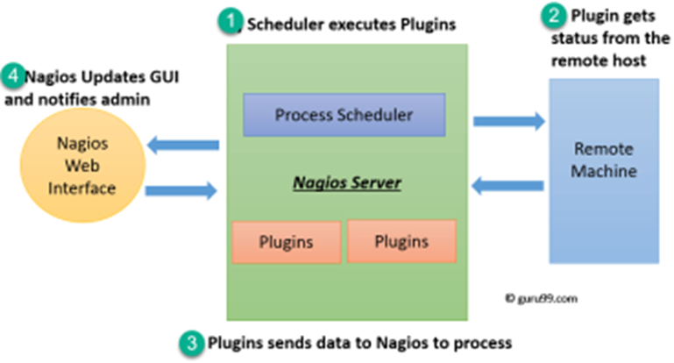

1. The scheduler is a component of the server part of Nagios. It sends a signal to execute the plugins at the remote host.

2. The plugin gets the status from the remote host

3. The plugin sends the data to the process scheduler

4. The process scheduler updates the GUI and notifications are sent to admins.

24 **Installation of Nagios**

**Prerequisites:** AWS Free Tier

Steps:

1. Create an Amazon Linux EC2 Instance in AWS and name it - nagios-host

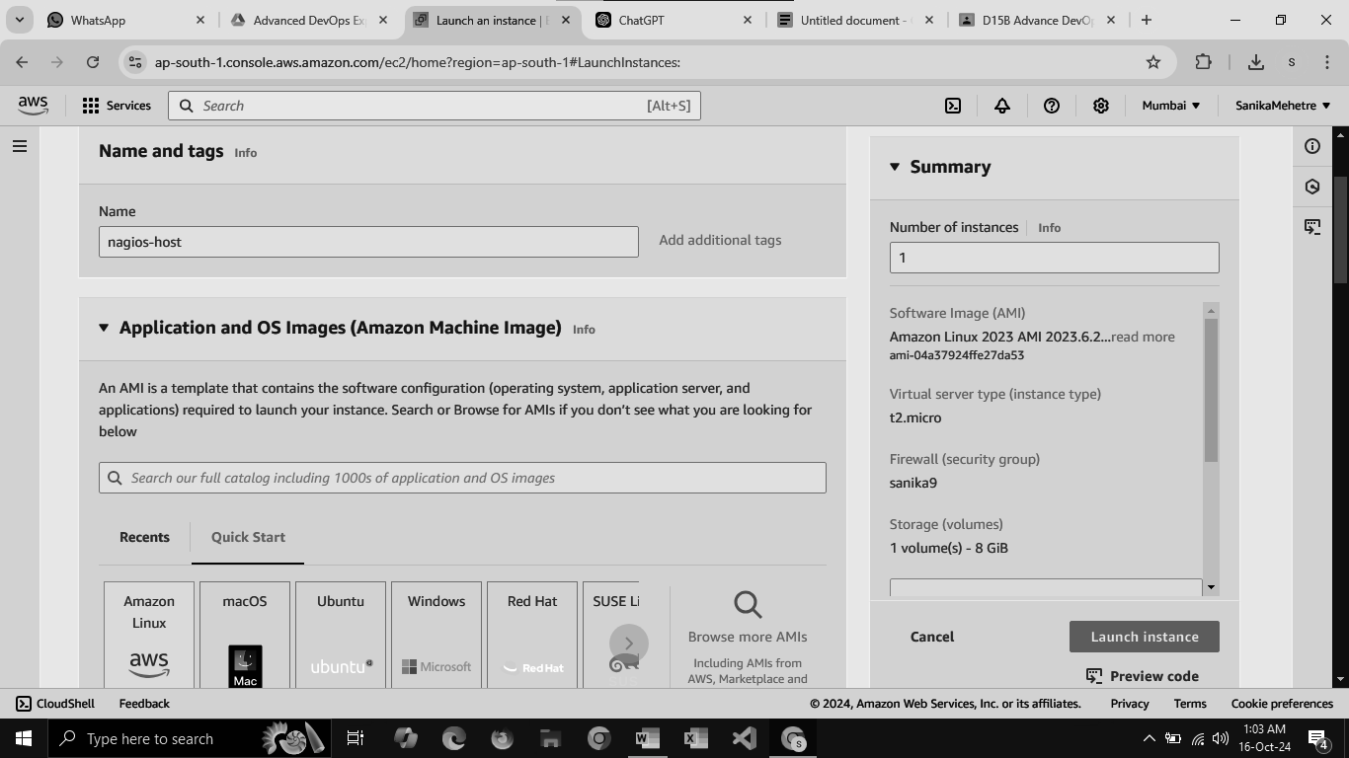

2. Under Security Group, make sure HTTP, HTTPS, SSH, ICMP are open from everywhere.

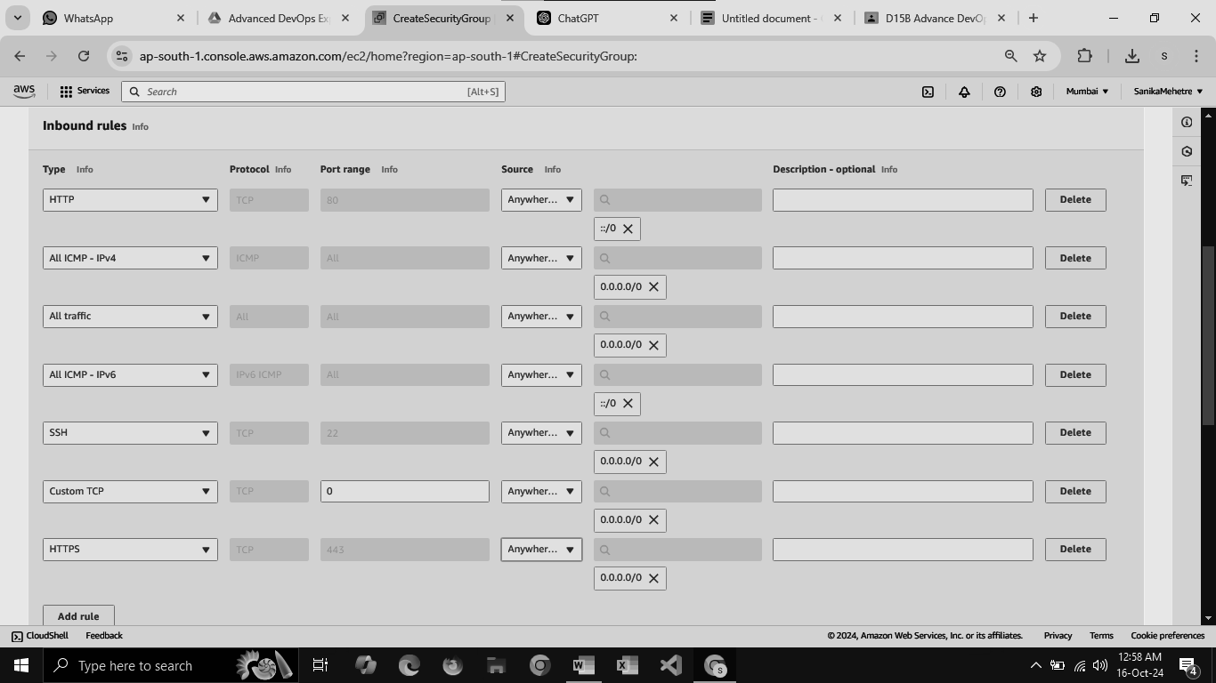

You have to edit the inbound rules of the specified Security Group for this.

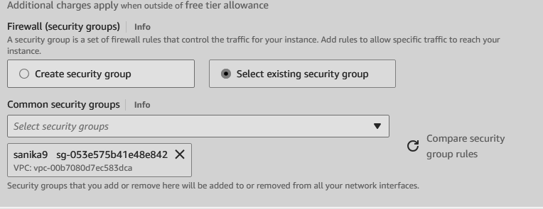

3. SSH into Your EC2 instance or simply use EC2 Instance Connect from the browser.

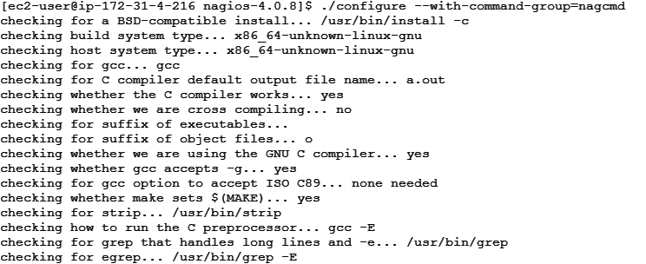

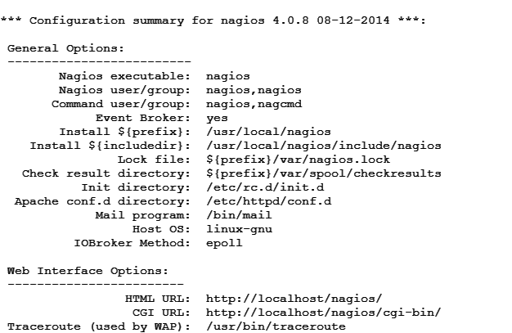

4. Update the package indices and install the following packages using yum

sudo yum update

sudo yum install httpd php

sudo yum install gcc glibc glibc-common

sudo yum install gd gd-devel

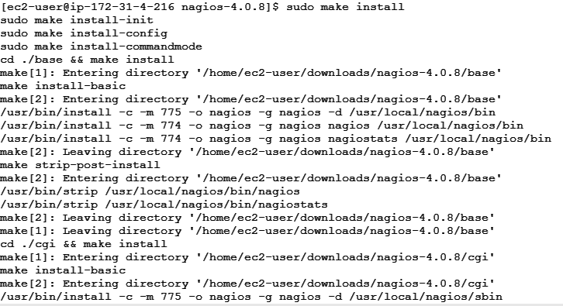

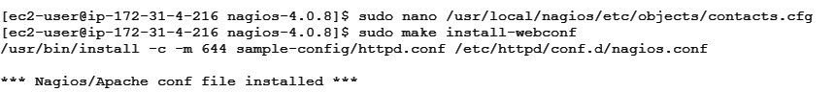

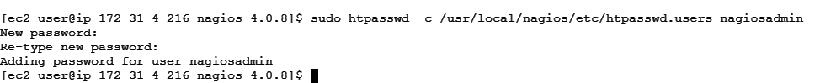



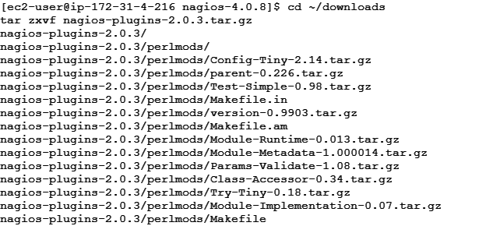

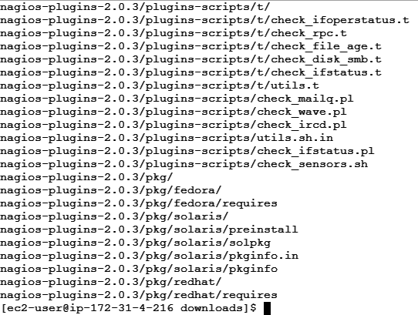

5. Create a new Nagios User with its password. You’ll have to enter the password twice for confirmation.

sudo adduser -m nagios

sudo passwd nagios

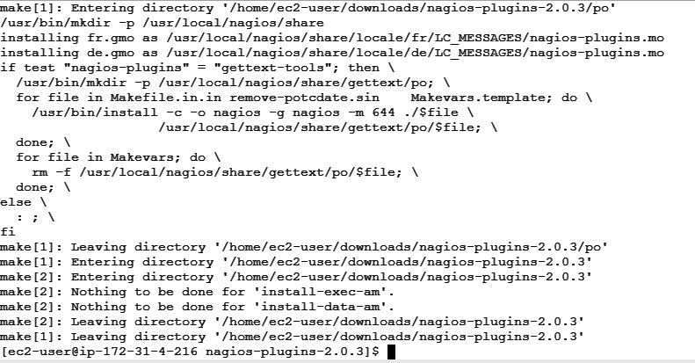

6. Create a new user group

sudo groupadd nagcmd

7. Use these commands so that you don’t have to use sudo for Apache and Nagios

sudo usermod -a -G nagcmd nagios

sudo usermod -a -G nagcmd apache

8. Create a new directory for Nagios downloads

mkdir ~/downloads

cd ~/downloads

9. Use wget to download the source zip files.

wget

http://prdownloads.sourceforge.net/sourceforge/nagios/nagios-4.0.8.tar. gz

wget http://nagios-plugins.org/download/nagios-plugins-2.0.3.tar.gz

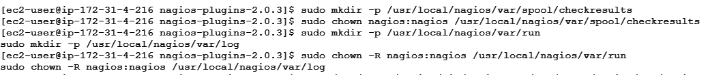

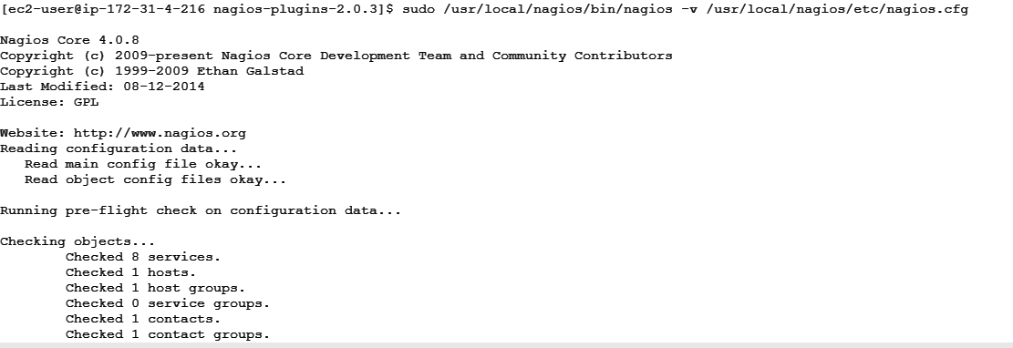

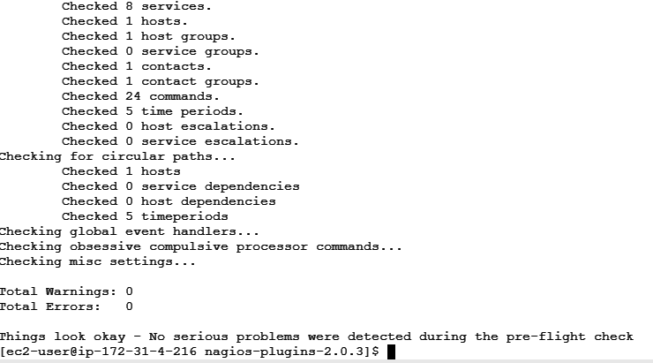

10. Use tar to unzip and change to that directory.

tar zxvf nagios-4.0.8.tar.gz

11. Run the configuration script with the same group name you previously created.

./configure --with-command-group=nagcmd

12. Compile the source code.

make all

13. Install binaries, init script and sample config files. Lastly, set permissions on the external command directory.

sudo make install

sudo make install-init

sudo make install-config

sudo make install-commandmode

14. Edit the config file and change the email address.

sudo nano /usr/local/nagios/etc/objects/contacts.cfg

15. Configure the web interface.

sudo make install-webconf

16. Create a nagiosadmin account for nagios login along with password. You’ll have to specify the password twice.

sudo htpasswd -c /usr/local/nagios/etc/htpasswd.users nagiosadmin

17. Restart Apache

sudo service httpd restart

18. Go back to the downloads folder and unzip the plugins zip file.

cd ~/downloads

tar zxvf nagios-plugins-2.0.3.tar.gz

19. Compile and install plugins

cd nagios-plugins-2.0.3

./configure --with-nagios-user=nagios --with-nagios-group=nagios make

sudo make install

20. Start Nagios

Add Nagios to the list of system services

sudo chkconfig --add nagios

sudo chkconfig nagios on

Verify the sample configuration files

sudo /usr/local/nagios/bin/nagios -v /usr/local/nagios/etc/nagios.cfg If there are no errors, you can go ahead and start Nagios.

sudo service nagios start



21. Check the status of Nagios

sudo systemctl status nagios

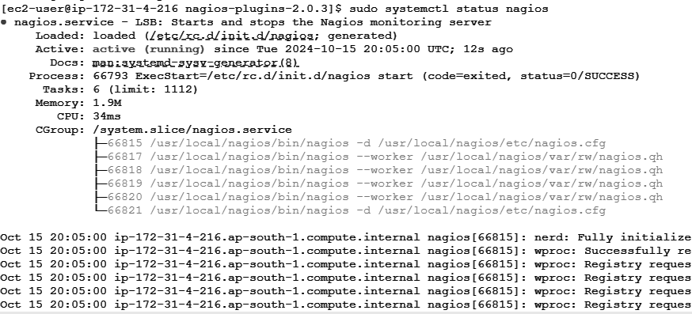

22. Go back to EC2 Console and copy the Public IP address of this instance

23. Open up your browser and look for **http://<your_public_ip_address>/nagios**

Enter username as nagiosadmin and password which you set in Step 16.

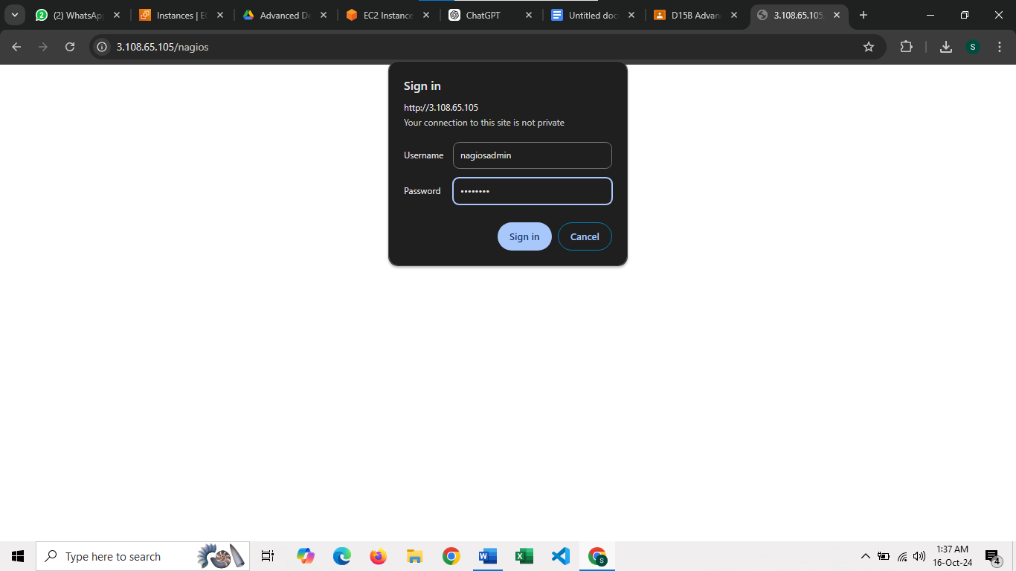

.After entering the correct credentials, you will see this page.

This means that Nagios was correctly installed and configured with its plugins so far.

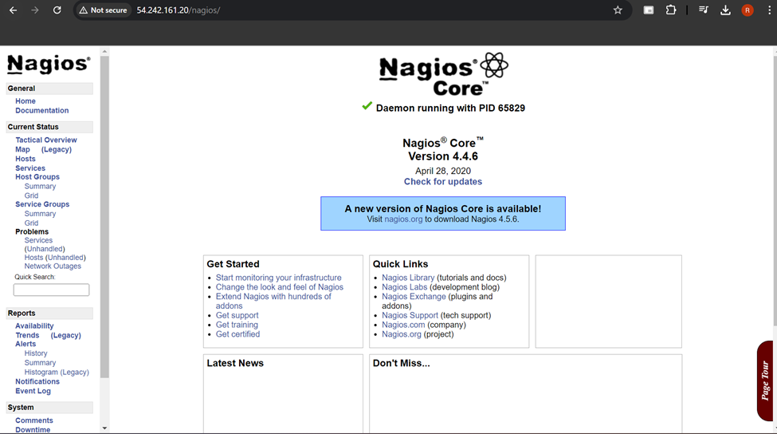

**Conclusion:**

Thus, we learned about Nagios and successfully set it up as a host on our Amazon Linux machine.